File System
Low Level Design Template

DMT/AD06/TMP

Project Code | Systems-1520
Project Name | File System

Prepared/Modified by | Role | Date of Preparation
Mariah Fernandes | CM | 07-01-14
Reviewed by | Role | Date of Review
Sneha Nair | Developer | 08/01/14
Approved by | Role | Date of Approval
Circulation List |  | Version Number of the template:1.6
Version Number | 1.4

Table of Contents

DMT/AD06/TMP 1
1. Description Of The Unit 3
2. Dependencies / Assumptions 17
3. Activity Diagrams 18
3.1 Create File In File System 18
3.2 List All Files From File System 19
3.3 Display File From File System 20
3.4 Delete File From File System 21
3.5 Modify File In File System 22
4. Messages 23

Description Of The Unit

The purpose of this project is to develop File system. File system provides layer of abstraction so that programs do not have direct access to raw disk. File system are data structures that manages files, directories-FAT table, Superblock. So the objective of this project is to create a 10 MB File system. The contents of the file system are:
- FAT (File Allocation Table) that stores details about all files present in root.
- Data blocks which will occupy the remaining space.

File system provides for a login menu wherein user is allowed to login as admin or user.
If user selects admin login, system asks the user to enter password to verify admin authenticity. If admin is successfully authenticated, admin is allowed to perform various operations like creating the root file, adding users to the system and viewing the error log.
If user selects user login, system redirects user to the general working of the file system. Here, user is allowed to perform several operations like creating a file, deleting a file, modifying a file, listing all files present in the root file as well as viewing the contents of a specific file.

File system allows the following operations to be performed:

Create Root File:

Select option:

After checking whether a root file exists or not.
If not, this use case is initiated.

Select action:

If root file does not exist, user is asked if he wants to create a root file.
Action Description:
- On being run, the system first checks if the root file exists or not.
- If not, system asks the user if he wants to create a root file.
- If the user selects yes, a root file of size 10MB is created.
- If the user selects no, root file is not created and the system exits.
Submit:

Before creating the root file, system validates if 10 MB of free space is available.

Quit:

If the user does not want to create a new root file, the system exits.

Alternative Flows
Alternate Flow 1:

Entry Point:
User runs the file system.

Condition:
Free space of 10 MB is not available in memory.

Action Description:
System displays error message to the user, “Not enough space in memory” and logs the same in the error log file.

Exit Point:
System exits as root file itself could not be created.

Alternate Flow 2:

Entry Point:
User runs the file system.

Condition:
Root file already exists.

Action Description:
System displays message to the user, “Root file exists”, loads the root file and displays the driver module.

Exit Point:
System exits as root file itself could not be created

Create File

Select option.

When a user selects the create file option, this use case is initiated.

Select action.

User is allowed to enter a file name and its corresponding contents.
Action Description:
- On being selected, the user is allowed to enter a name for the file to be created.
- If the file name entered does not already exist and length of file name does not exceed 255 characters, a file with that name gets created.
- System then allows the user to enter contents into that file.
- System records the corresponding timestamp in Inode entry of that file.
- System displays menu of all available operations to the user.

Submit:

- Before creating the file, system validates if number of files in the root has reached its maximum (100).
- When user enters file name, system checks if length of file name exceeds 255 characters.
- When user enters contents for his file, system validates if that content makes the root file exceed its maximum size of 10 MB. If so, system alerts the user of the same and does not allow the file to get created.

Quit:

When a file is successfully created, system displays menu of all available operations that can be performed on the file.

Alternative Flows
Alternate Flow 1
Entry Point:
User selects the use case Create File

Condition:
File name entered already exists in root.

Action Description:
System displays error message to the user, “File name already exists” and logs the same in the error log file.
User is then asked to enter a new file name.

Exit Point:
File is not created and System asks the user to enter a new file name.

Alternate Flow 2

Entry Point:

User selects the use case Create File

Condition:

Number of files in the root exceeds 100.

Action Description:

System displays message to the user, “Maximum file limit reached”. Cannot create more files and displays the driver module.

Exit Point:

File is not created and System displays the driver module.

Alternate Flow 3

Entry Point:

User selects the use case Create File

Condition:

Size of root file exceeds 10 MB

Action Description:

System displays message to the user, “Not enough space in root file

Exit Point:

File is not created and System displays the driver module.

List Files

Select option:

When a user selects the list files option, this use case is initiated.

Select action:

System displays names of all files present in the root file.

Action Description:
- On being selected, system fetches all files from the root file.
- System displays names of alI files to the user.
- System then displays menu of all available operations to the user.

Submit:

Before listing the files, system checks if root file contains any files.

Quit:

When the file names are successfully displayed, system displays menu of all available operations that can be performed on the file.

Alternative Flows
Alternate Flow 1

Entry Point:

User selects the use case List Files

Condition:

Root file is empty

Action Description:

System displays error message to the user, “No files present in root file” and logs the same in the error log file.

Exit Point:

No file is listed and System displays menu of all available operations to the user

Display File

Select option:

When a user selects the display file option, this use case is initiated.

Select action:

System displays contents selected file present in the root file.

Action Description:
- On being selected, system asks the user to enter name of the file whose contents he wants to view.
- System fetches contents of that file from the root file.
- System displays file details as well as contents to the user.
- System then displays menu of all available operations to the user.
Submit :

Before displaying contents of the file, system checks if the file is present in the root.

Quit:

When the file contents are successfully displayed, system displays menu of all available operations that can be performed on the file.

Alternative Flows
Alternate Flow 1

Entry Point:
User selects the use case Display Specific File

Condition:
File name entered is not present in Root file

Action Description:
System displays error message to the user, “Files does not exist” and logs the same in the error log file

Exit Point:
No contents are displayed and System displays menu of all available operations to the user

Delete File

Select option:

When a user selects the delete file option, this use case is initiated.

Select action:

System removes a file and its contents from the root
Action Description:
- On being selected, system asks the user to enter name of the file whose contents he wants to delete.
- If file exists in root, System removes details and contents of that file from the root file.
- System then displays menu of all available operations to the user.
Submit:

System checks if the file is present in the root and only then deletes it.

Quit:

When the details and contents of the file are successfully deleted, system displays menu of all available operations that can be performed on the file.

Alternative Flows
Alternate Flow 1:

Entry Point:

User selects the use case Delete File

Condition:

File name entered is not present in Root file

Action Description:

System displays error message to the user, “Files does not exist” and logs the same in the error log file.

Exit Point:

No contents are deleted and System displays menu of all available operations to the user

Alternate Flow 2:

Entry Point:

User selects the use case Delete File

Condition:

File mode is read only

Action Description:

System displays error message to the user, “File is read-only and cannot be deleted” and logs the same in the error log file

Exit Point:

No contents are deleted and System displays menu of all available operations to the user

Modify File

Select option:

When a user selects the update file option, this use case is initiated.

Select action:

System updates a file by either overwriting it or appending new contents to existing data in file.
Action Description:
- On being selected, system asks the user to enter name of the file whose contents he wants to update.
- If file exists in root, System gives the user two options: to change the file mode or to modify the file.
- If the user selects the change mode option, System fetches the file.
- System then asks the user for the access permission he wants to assign to the file.
- The changes are updated in the root file.
- System then displays menu of all available operations to the user.
- If the user selects the modify file option, System gives the user two options: to append contents to file or to overwrite the file.
- User selects the mode in which he wants to modify the file.
- System then allows user to add the new content to the file.
- If mode selected is append file, system adds new content to the end of existing content of file.
- If mode selected is overwrite file, system deletes existing content of file and adds new content to the file.
- The corresponding modification timestamp is logged in the FAT table.
- New file content is updated in the root file.
- System then displays menu of all available operations to the user.

Submit :

- System checks if the file is present in the root and only then updates it.
- System checks if the file is in read-write mode and only then updates it.

Quit:

When the details and contents of the file are successfully updated, system displays menu of all available operations that can be performed on the file.

Alternate Flow 1

Entry Point:

User selects the use case Update File

Condition:

File name entered is not present in Root file

Action Description:

System displays error message to the user, “Files does not exist” and logs the same in the error log file

Exit Point:

No contents are updated and System displays menu of all available operations to the user
Alternate Flow 2

Entry Point:

User selects the use case Update File

Condition:

File mode is read only

Action Description:

System displays error message to the user, “File is read-only and cannot be updated” and logs the same in the error log file

Exit Point:
No contents are updated and System displays menu of all available operations to the user

Dependencies / Assumptions

Dependencies:

Module: Create file, list all files, display specific file, delete file, update file

Use case name: Create root file

Impact: If root file is not created, none of the above operations on files can be performed.

Assumptions:

- Microsoft Visual Studio is present on the system.
- Memory will be available to create root file
- Memory will be available to create a new file

Activity Diagrams

3.1 Create File In File System

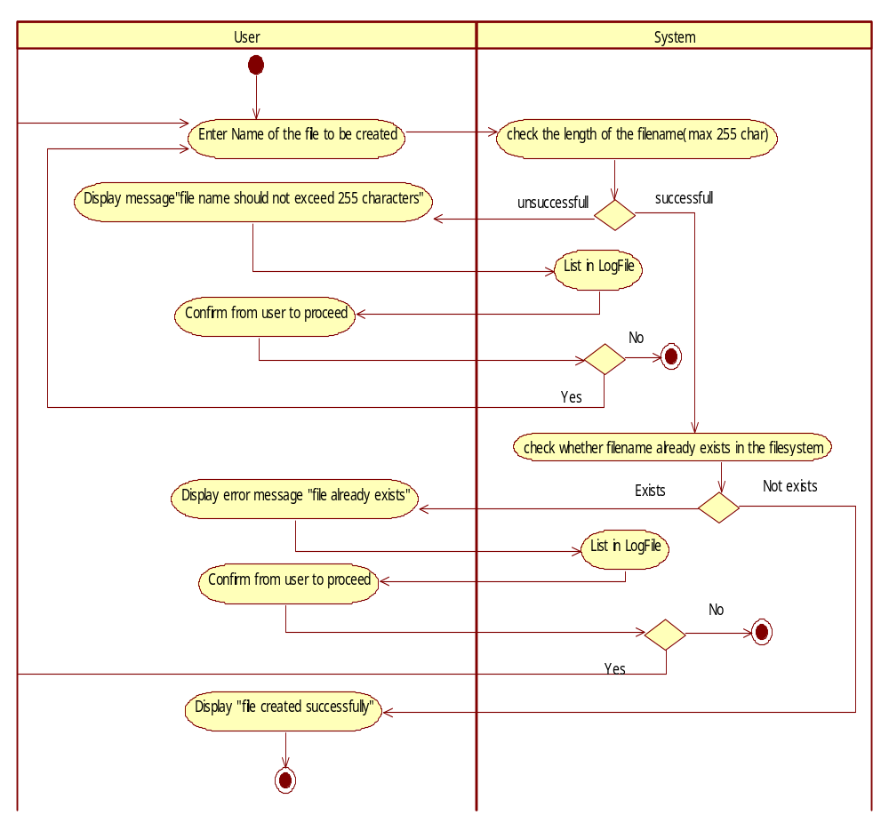

3.2 List All Files From File System

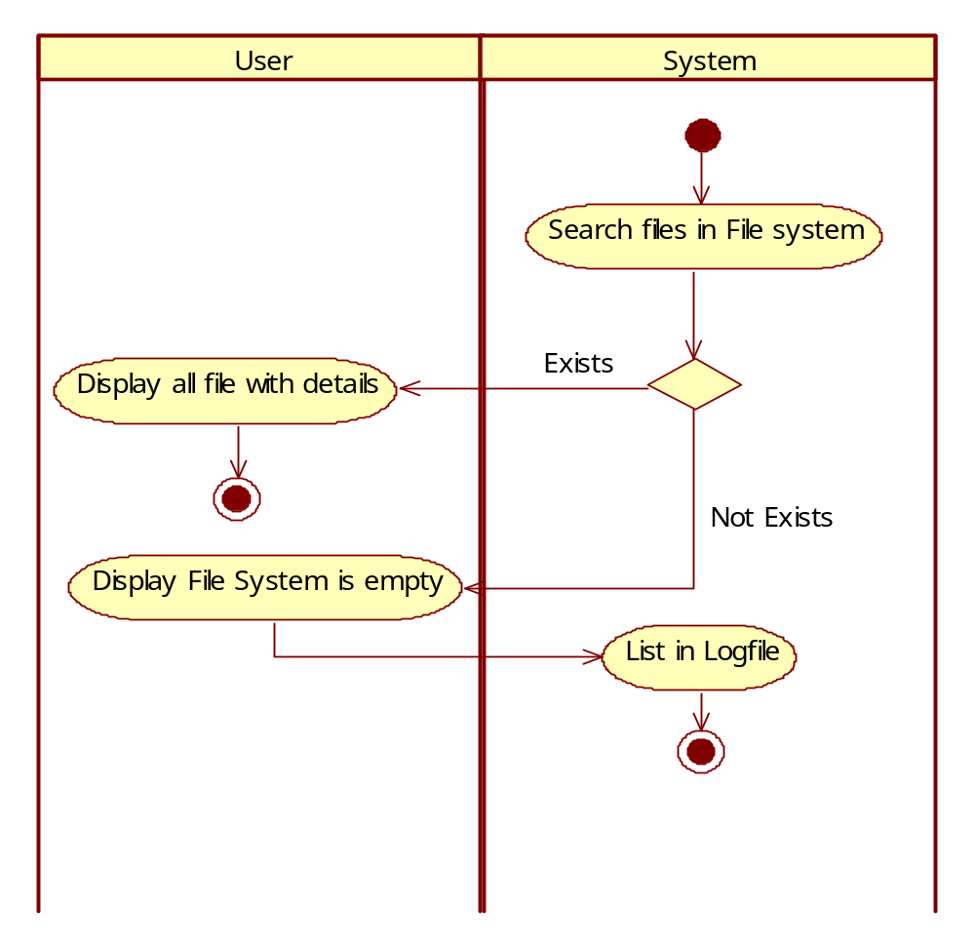

3.3 Display File From File System
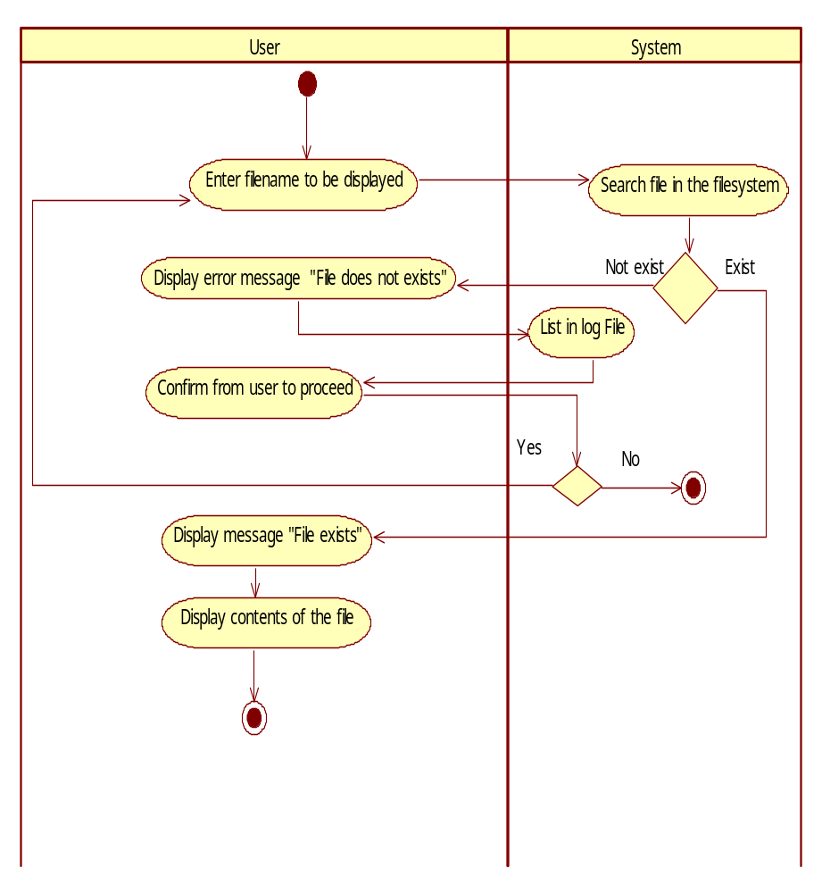

3.4 Delete File From File System
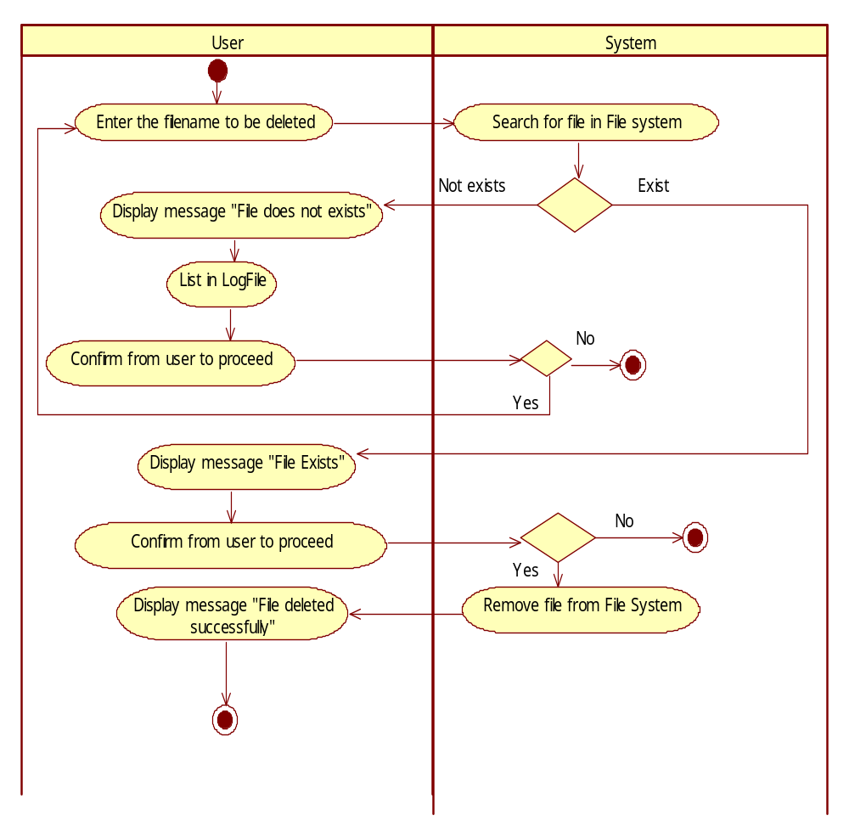

3.5 Modify File In File System
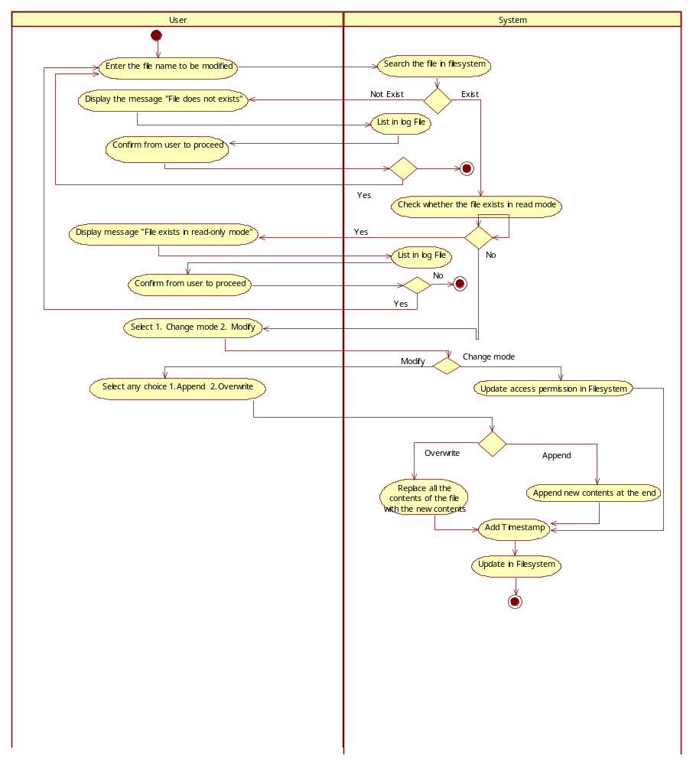

Messages

#. | Type | Message Text
 | <Warning/Information/Validation/Error>
1 | Warning | File System Does Not Exist..!!
2 | Information | File System Created..!!
3 | Information | Number of data blocks created : 2546
4 | Information | Number of data blocks created : 2546  Data Blocks are Copied to the File System..!!
5 | Information | Copying FAT Table to the File System..!!  FAT Table is Copied to the File System..!!
6 | Information | File is opened to write..  Enter the data..  Press (Ctrl + z) to save the file..
7 | Information | File Created..!!
8 | Information | Press any key to continue..!!
9 | Information | File Contents are:|  End of File..!!
10 | Information | File Exists..!!  Do you wish to delete this file?(Y/N) :
11 | Warning | File Not Deleted..!!
12 | Information | File is Deleted..!!
13 | Error | No File Exist in the System..!!
14 | Error | File Does Not Exist..!!
15 | Information | Copying Data Blocks to the File System..!!  Data Blocks are Copied to the File System..!!
16 | Information | Copying FAT Table to the File System..!!  FAT Table is Copied to the File System..!!
17 | Information | Thank You..!!
REVISION HISTORY OF THE WORK PRODUCT
<to be maintained by projects>

# | Date | Version # | Section Changed | Details of changes made | Approved By
1 | 07-01-14 | 1.1 | Messages | Type of message changed to “warning” where required
2 | 07-01-14 | 1.2 | Table of contents | Sections not pertaining to the project are removed
3 | 09-01-14 | 1.3 | Description of Unit | Addition of login functionality
4 | 09-01-14 | 1.4 | Entire document | Proper formatting implemented

